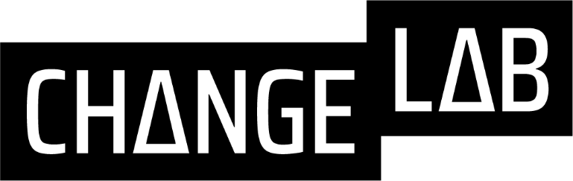

Undergraduate Research Assistant Application

If you are interested in joining the Change Lab please fill out and submit this form to Dr. Motz’s email (bmotz@indiana.edu) along with your resume or CV.

Name: | Email:
Phone Number: | Year in School:
Expected Graduation Date: | Major:
Minor/Certificate (if applicable):

- Please describe any technical skills you currently have (e.g., computer skills, programming languages, data analysis) or any actions you are currently taking to acquire technical skills (e.g., taking a class, teaching yourself to code, etc.). For any skills you include please also list your proficiency.

- Optional. If you have any previous research experience, please list it here.

- Please take a moment to read our values statement:

“We value diversity and work to create an inclusive environment where people of different backgrounds, beliefs, and experiences can thrive. We encourage members of the Change Lab to seek out opportunities to learn from those with perspectives different from their own. We value constructive feedback. We become enchanted by what we don’t know.
Our work is responsible and purpose-driven. We aim to answer questions and solve problems that are relevant to human lives. We try to scale and extend experimental research practices to people and settings that have historically been marginalized in the study of learning and behavior. We value transparency and methodological rigor.”

In what ways does this statement align with your own personal values?

- Involvement in service is highly valued in the Change Lab, however we understand that not everyone is able to regularly engage with a service-based organization, non-profit, or activity. Please describe either your involvement in a service effort OR a cause which you are passionate about.

- Finally, what interests you? Please select an article authored by someone in the Change Lab, summarize the article in your own words, tell us what interests you about it, and ask at least one question about it.

